# Operational Concept Description (OCD)

**Construction Meeting Minutes App**

**Team 6**

Pradeep Muruganandam - Prototyper and Quality Focal Point  
Dennis Evans - System Architect, Project Manager  
Pavan Lingambudhi Seshadri Vasan - Requirements Engineer   
Sideok You - Feasibility Analyst   
Shengyi Chen - Operational Concept Engineer  
Nguyen Tran - IIV & V

Qichen Gu - Life Cycle Planner

**Dec 7th 2015**

# Version History

| Date | Author | Version | Changes made | Rationale |
| --- | --- | --- | --- | --- |
| 10/14/15 | Shengyi Chen | 1.0 | * Original template for use | * Initial draft for use |
| 10/15/15 | Shengyi Chen | 1.1 | * Added section 2.1, 2.2 and 3.3 | * Add Benefit Chain, System Boundary and Element Relationship Diagram |
| 10/15/15 | Shengyi Chen | 1.2 | * Added section 3.4 | * Add Organizational Transformation and Operational Transformation |
| 10/15/15 | Shengyi Chen | 1.3 | * Added 3.2.0, 3.2.1, 3.1.3, 3.3.2 | * Add Capability Goals, Level of Service Goals, Current Business Workflow and New System Business Workflow |
| 10/18/15 | Shengyi Chen | 1.4 | * Fixed 2, 2.1, 2.3, 3.2.2, 3.3.2 | * Fixed notation and bad expression of Initiative of benefit chain, identification and related stakeholders of System boundary diagram, expression of organizational goals and error of the line of current system business workflow |
| 12/07/15 | Shengyi Chen | 1.5 | * Updated 2.2, 2.3, 3.2.0, 3.2.1, 3.2.2, 3.2.4, 3.3.1, 3.3.2, 3.4.1, 3.4.2 | * Updated system capability description, system boundary diagram, capability goals, level of service goals, organizational goals, relation to current system, element relationship diagram, business workflow, organizational transformations, operational transformations |

# Table of Contents

Operational Concept Description (OCD) i

Version History ii

Table of Contents iii

Table of Tables iv

Table of Figures v

1. Introduction 1

1.1 Purpose of the OCD 1

1.2 Status of the OCD 1

2. Shared Vision 2

2.1 Benefits Chain 3

2.2 System Capability Description 4

2.3 System Boundary and Environment 5

3. System Transformation 6

3.1 Information on Current System 7

3.2 System Objectives, Constraints and Priorities 8

3.3 Proposed New Operational Concept 13

3.4 Organizational and Operational Implications 15

# Table of Tables

Table 1: The Program Model 2

*Tbale2: The Capability Model…………………………………………………………………………………………………….7*

Table 3: Level of Service Goals 7

Table 4: Relation toCurrent System………………………………………………………………………………………………9

# Table of Figures

Figure 1: Benefits Chain Diagram of Construction Meeting Minutes App 3

Figure 2: System Boundary and Environment Diagram of Construction Meeting Minutes App 4

Figure 3: Business Workflow Diagram of Current System…………………………………………………………………..6

Figure 4: Element Relationship Diagram of Our New System………………………………………………………………10

Figure 5: Business Workflow Diagram of Our New System…………………………………………………………………12

### Introduction

#### Purpose of the OCD

This document provides, in detail, the shared visions and goals of the stakeholders of the Department of Public Works (DPW). The success-critical stakeholders of the project are Crystal Munson, as the project owner, manager and representative; the DPW workers and volunteers, as contractors; we team 6, as Developers.

#### Status of the OCD

The status of the OCD is currently at the As-Built version number 1.5 of the development phase. Everything is finished and finalized.

### Shared Vision

Table 1: The Program Model

|  |  |  |  |
| --- | --- | --- | --- |
| Assumption:  1. Everyone has a android smartphone  2. Paperwork takes time  3. Internet access is available via WiFi or Data network  4. The mobile has an ability to synchronize data  5. Manager and Employee is familiar with using Web App | | | |
| Stakeholders | Initiatives | Value Propositions | Beneficiaries |
| 1. Project Owner 2. Representative 3. Manager 4. Contractor 5. Developer | 1. Design & Develop New System with different view for Manager and Contractors 2. Received Proper Training 3. Use new database to store the data 4. Develop new searching feature 5. Use new Search function frequently | * Ease of Use * Improve data storing efficiency * Improve data searching efficiency * Improve productivity | * Manager * Architect * Contractor |

#### Benefits Chain

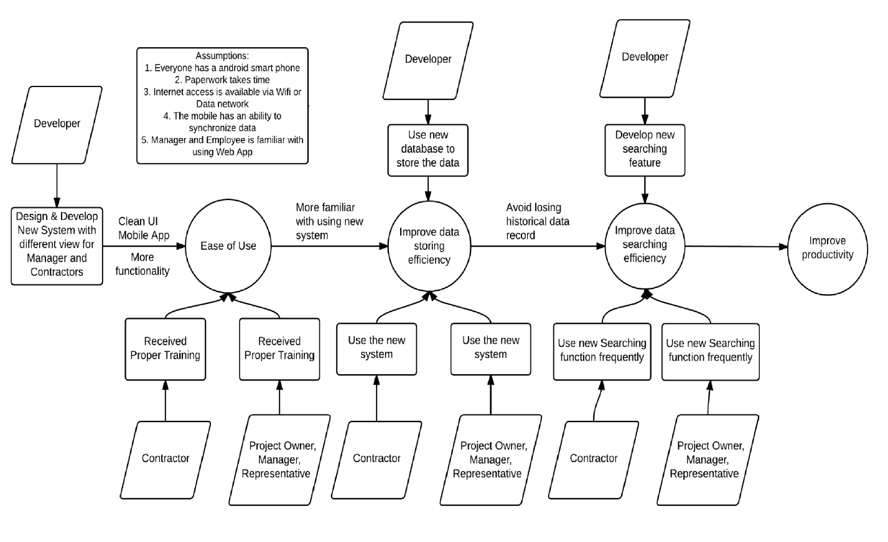

Figure 1: Benefits Chain Diagram of Construction Meeting Minutes App

#### System Capability Description

* User can login
* Manager can approve signup
* Manager can approve comment
* User can generate logs
* User can send notification
* User can post on Discussion
* Manager can create Project, Task and Meeting
* Manager can assign Project, Task and Meeting
* Manager can delete Project, Task and Meeting
* Manager can view all Project, Task and Meeting
* Contractors can view Project, Task and Meeting related or assigned to them
* Contractors can report comment
* User can edit profile
* User can search meeting by topics
* User can edit task categories
* User can get automated generated PDF report.
* User can save status and progress of any project, meeting or tasks on offline storage.

#### System Boundary and Environment

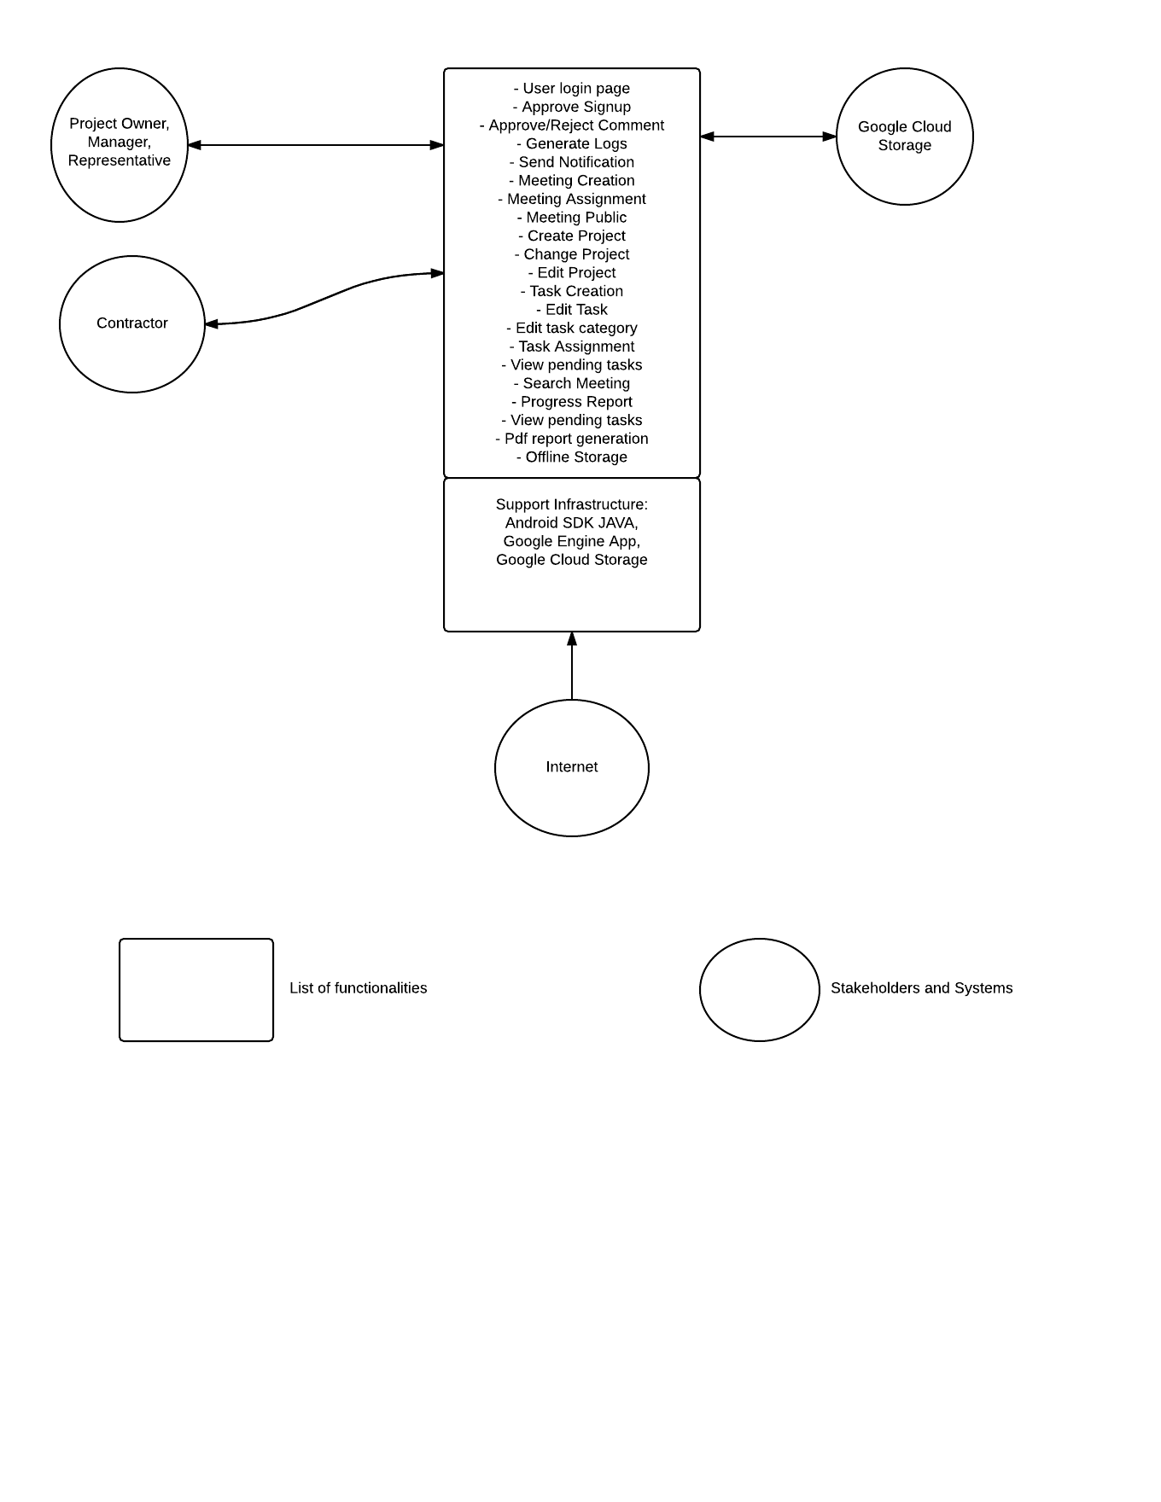

Figure 2: System Boundary and Environment Diagram of Construction Meeting Minutes App

### System Transformation

#### Information on Current System

##### Infrastructure

Primavera (Oracle, SQL Server and Adaptive SQL Server) is the only infrastructure of the current system.

##### Artifacts

For current system, there is only one single view that only manager can login and create the meeting. Then she will write all meeting minutes on the hand-written notes and give them to the contractors. There is simple function for meeting management: Manager can check the status of the recent created meeting or delete recent one. There is no searching feature and some old meeting records might be cleared automatically because of the limit of database.

##### Current Business Workflow

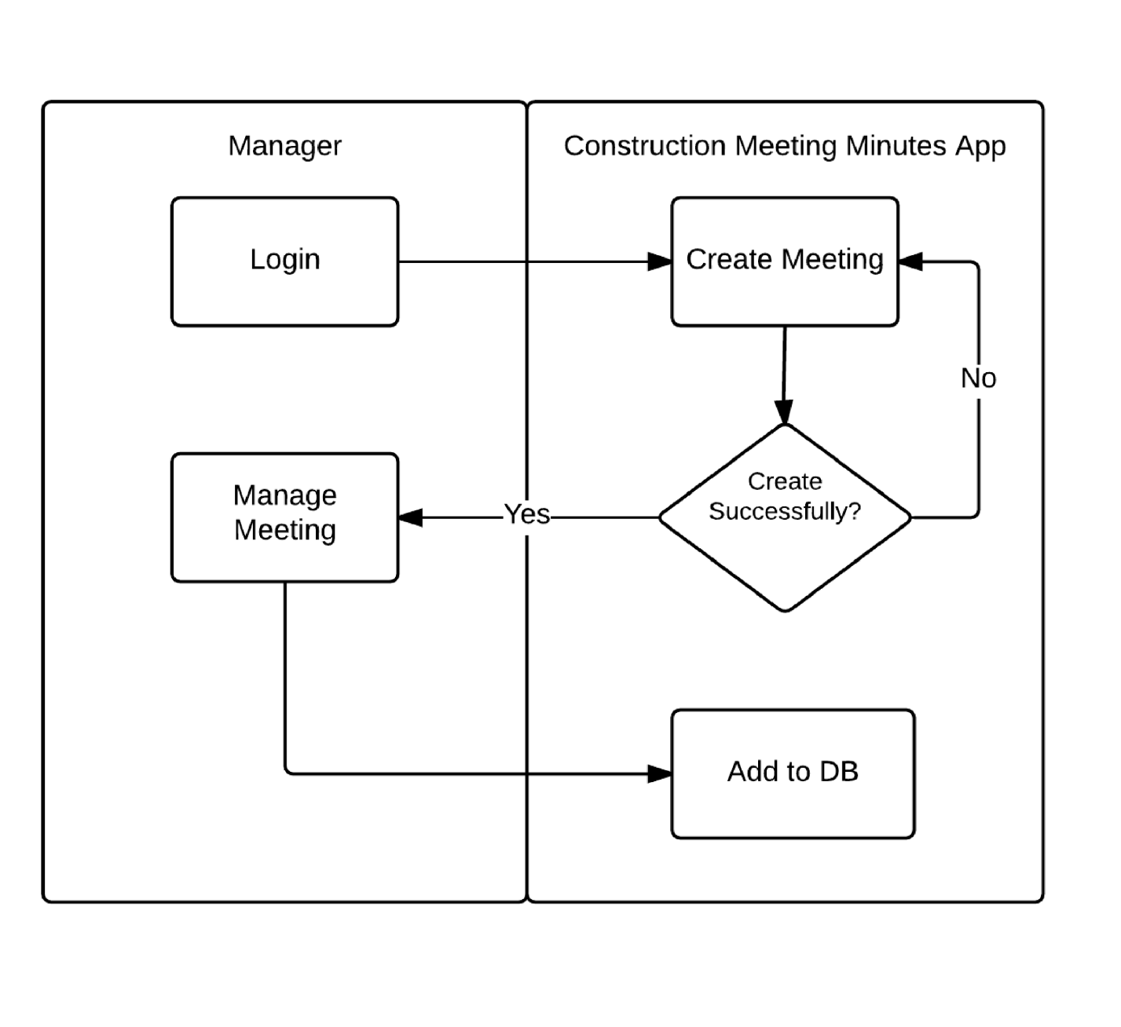

Figure 3: Business Workflow Diagram of Current System

#### System Objectives, Constraints and Priorities\Capability Goals

**3.2.0 Capability Goals**

**Table 2: The Capability Goals**

|  |  |
| --- | --- |
| **Capability Goals** | **Priority Level** |
| **OC-1 Log Generation:** The system is capable of generating the logs once User types them for any meeting | Must have |
| **OC-2 Discussion Generation:** The system is capable of generating the discussion once User posts it. | Must have |
| **OC-3 Project, Meeting and Task Generation:** The system is capable of creating project meeting and task and adding them to the DB once Manager creates them. | Must have |
| **OC-4 Project, Meeting and Task Assignation:** The system is capable of assigning project, meeting and task to the Contractors. | Must have |
| **OC-5 Project, Meeting and Task Searching:** The system is capable of searching project, meeting and task by its topic. | Must have |
| **OC-6 Project, Meeting and Task Deletion:** The system is capable of deleting project, meeting or task by its topic. | Must have |
| **OC-7 Project Meeting and Task History Storage:** The system is capable of storing and keeping every history of project, meeting and task records to the DB. | Must have |
| **OC-8 Notification Generation:** The system is capable of generating notification to the Contractors once the meeting or task is assigned to them. | Must have |
| **OC-9 PDF report Generation:** The system is capable of generating PDF report once the details of project, meeting and task are created. | Must have |
| **OC-10 Offline Storage:** The system is capable of generating offline storage for unsaved project, meeting or task when there is no Wifi or Internet. | Must have |
| **OC-11 Signup Request Approve:** The system is capable of transferring the request of contractors to the manager’s account and authorize the contractors’ access account and password once manager approve the request. | Must have |
| **OC-12 Comment Approve:** The system is capable of transferring the comment from contractors to manager’s account and making the task to be completed status once the manager approves this comment. | Must have |
| **OC-13 Task Categories Edition:** The system is capable of editing the task categories and adding them to the DB once manager or contractors edit them. | Must have |

##### Level of Service Goals

Table 3: Level of Service Goals

|  |  |  |
| --- | --- | --- |
| **Level of Service Goals** | **Priority Level** | **Referred WinWin Agreements** |
| Log Generation | High |  |
| Discussion Generation | High | As a contractor, I can send message to the manager so that I can ask question and/or correct issues on the last minutes |
| Project, Meeting and Task Generation | High | As a manager, I can create meeting.  As a manager, I can create a new project |
| Project, Meeting and Task Assignation | High | As a manager, I can send out the meeting minutes to all the attendees so that everyone knows what to do based on their checklist |
| Project, Meeting and Task Searching | High | As a Manager I can access the meeting logs quickly and track the progress of a project quickly so that I can make decisions after having all reports thoroughly and send out instructions to appropriate personnel |
| Project, Meeting and Task Deletion | Medium | As a Manager, I can delete meetings. |
| Project, Meeting and Task History Storage | High | As a Manager I can access the meeting logs quickly and track the progress of a project quickly so that I can make decisions after having all reports thoroughly and send out instructions to appropriate personnel |
| Notification Generation | High | As a manager, I can send out the meeting minutes to all the attendees so that everyone knows what to do based on their  checklist |
| PDF report Generation | High | As a Manager, I can get automated generated PDF report of details of specific project, meeting or task. |
| Offline Storage | High | As a Manager or Contractor, I can save unsaved progress or status of any project, meeting or task. |
| Signup Request Approve | High | As a manager, I can approve or disapprove the request of signup from contractors. |
| Comment Approve | High | As a manager, I can approve or reject a contractor's comment on a specific task, where a comment is a request for task completion. |
| Task Categories Edition | High | As a manager, I can edit task categories and add them to the list of categories. |

##### 

##### Organizational Goals

**OG-1:** Manager can have a smooth and efficient interaction with contractors on the related meetings.

**OG-2:** Manager can check the progress immediately after contractors report it.

**OG-3:** Contractor get a notification which shown on the tab on their phone once Manager assign some meetings to them.

**OG-4:** The organization can save time and cost by using Notification system instead of using paper to hand out the meeting information

**OG-5:** The organization can know the difficulties and problem met during each project or each meeting by looking at the post on the Discussion.

**OG-6:** The organization can save time by searching project, meeting or task by its topic instead of looking for it one by one sequentially.

**OG-7:** The organization can save time by generating task categories which actually speed up the searching process of project meeting or task.

**OG-8:** The organization can save time by automating the process that contractor submit the request then manager can approve it or not.

**OG-9:** The organization can still hold the unsaved details or status of project meeting or task so that someone can continue it next time.

**OG-10:** The organization can mark the task to “Completed” by viewing the comment from contractor, which can be generated manually.

##### Constraints

**CO-1: Zero Cost**: Project Manager wants this project to be zero cost by using free Database and backend engine.

**CO-2: Android System**: Project Manager and most contractors use Android Phones so we need to build an Android App.

**CO-3: Java as Development Language**: Java will be used on the development of Android App.

##### Relation to Current System

Table 4: Relation to Current System

|  |  |  |
| --- | --- | --- |
| **Capabilities** | **Current System** | **New System** |
| Roles and Responsibilities | Only serve Manager | Serve both Manager and Contractors |
| User Interactions | Has only Meeting Minute Management and Login | Has Login page, Project Meeting Minute and Task Management, Discussion, Notification, Logs Page and Searching Feature, PDF report generation, Offline Storage, Task Categories, Signup Approve, Comment Approve, Profile Edit |
| Infrastructure | Primavera | Google Engine App, Google Cloud Storage |
| Stakeholder Essentials and Amenities | Project Owner  Manager  Representative  Developer | Project Owner  Manager  Representative  Contractors  Developer |
| Future Capabilities | Not applicable (will be replaced by the new system) | Maybe Chatting System |

#### Proposed New Operational Concept

##### Element Relationship Diagram

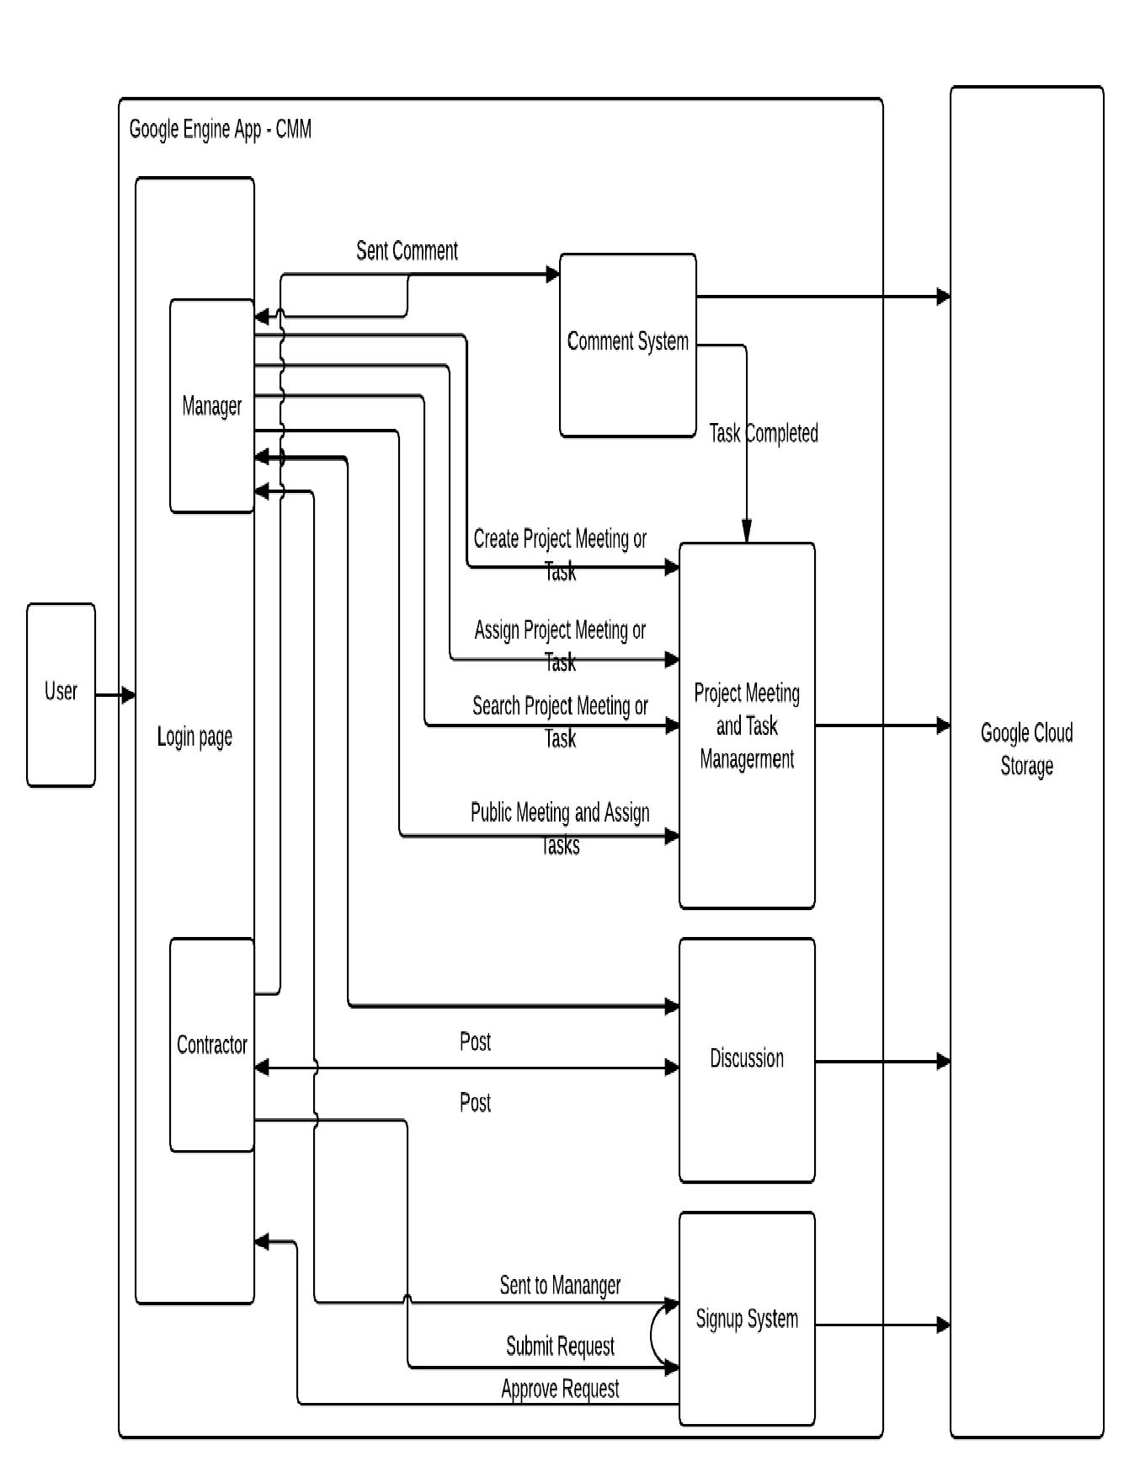

Figure 4: Element Relationship Diagram of Our New System

##### Business Workflows

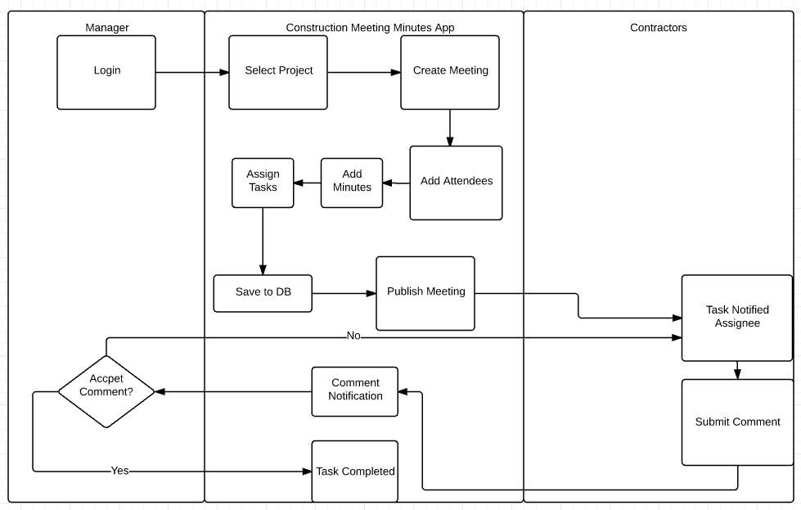

Figure 5: Business Workflow Diagram of Our New System

#### Organizational and Operational Implications

##### Organizational Transformations

* The need to purchase more cloud space to satisfy growing need storing history of every meeting record.
* The need to distinguish whether user is the Manager or Contractor.
* The need to keep Contractors only see the meeting that assigned to them
* Manager has authority to see all the meeting minutes.
* The need to add a Discussion board that every user can post on it.
* The need to add a Notification System which will notify according user when meeting associated is created, assigned or deleted.
* The need to add a Comment system which allow contractor to submit comments and manager can approve or disapprove them.
* The need to add a Signup system which allow contractor to submit requests of signup and manager can approve or disapprove them.
* The need to hire a new system maintainer to take care of the system
* The losing of history of meeting record is avoided, every record is kept
* The need to hire a database engineer that take care of the new cloud database
* The need to have a central server or local disk to store the offline progress of unsaved project, meeting or task

##### Operational Transformations

* Having the Manager and Contractor to login together rather than only Manager can login
* The notification will be generated and send to the Contractor once the Manager creates the meeting and task and publish it to the Contractor along with automated generated Pdf report rather than creating the meeting and write it to the paper and hand it out by hand
* The meeting will show the logs rather than only status and data is shown
* Contractor needs to report progress (comment) once he or she finished all or part of the meetings and manager can approve or disapprove this comment.
* The elimination of writing notes by hand but has a Pdf generating way to generate report automatically.